**How to Register for Classes- College Scheduler**

1. Log in to MySLCC and find the Register for Classes card.



If you don’t see this card, select Discover More.



And then search register for classes.



1. Select the Banner Registration or College Scheduler and click “Register Here”. Both will allow you to register.

**Professional Development Student Record Management**   
Salt Lake Community College  
Miller Campus—MPDC 110  
9750 South 300 West  
Sandy, UT 84070  
**Office Hours:** Mon—Fri 8:00am—4:30pm

*These steps will be for College Scheduler

3. Click Add Course button.



4.Search for your classes by subject, attribute, DegreeWorks, or by instructor.

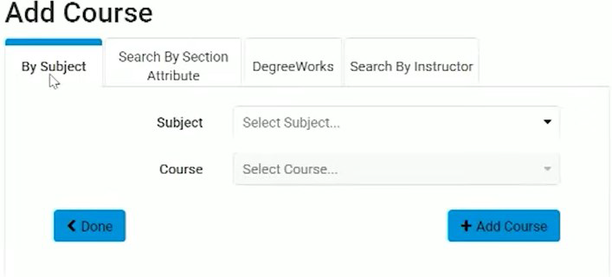

5. Select the +Add Course button to add the class to your schedule. The added courses will appear under courses on the right. When all your classes are added select Done.



To see course section information (dates & time), click the gear icon.

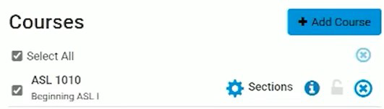

6. Once all course have been selected, click Generate Schedules.



All available sections will populate. Click View to review the detailed schedules.

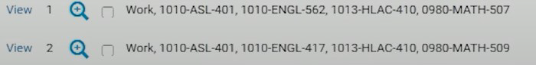

7. When selecting the course you want, click Send to Registration

Cart.

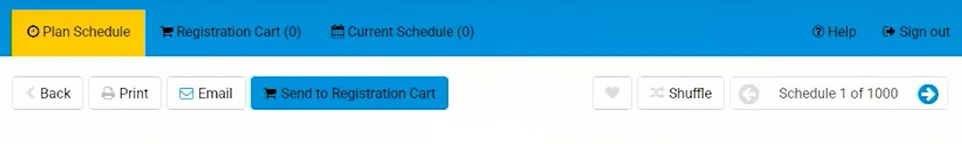

8. Once your schedule is complete, click Register and confirm.

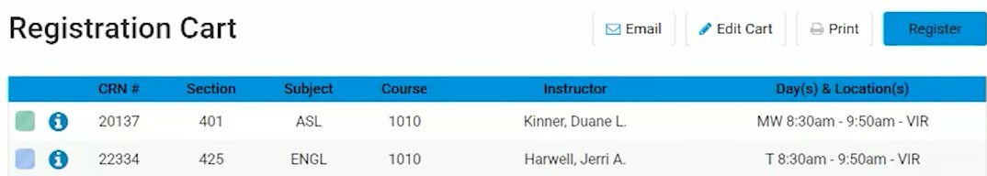

9. You will be taken to the Current Schedule page for a final review. You are now registered.



Note: If you need to drop a class or edit your registration, click the Edit or Drop Classes button.



You can change to the options in the drop down menu. Click Save when finished.